**CFD Simulation of Computer Room Air Conditioning: Our 2D Navier-Stokes Solver coupled with Energy Equation vs. Fluent Simulation**

**Han Li, Siliang Lu**

**School of Architecture, Carnegie Mellon University**

**ABSTRACT**

This paper presents 2D computational fluid dynamic (CFD) simulation models of the computer room air conditioning system (CRAC) used for a data center. The models were developed with our own Navier-Stokes solver as well as Fluent to investigate the airflow patterns as well as temperature distribution inside the data center.  Two cases with two different inlet velocities were compared to see a better CRAC configurations. The lid-driven cavity model was also developed with our own solver and Fluent to verify the appropriate implementation of energy equations in our own solver. The results show that supply air velocity with 45 degrees to the inlet has better cooling performance than that perpendicular to the inlet. In addition, comparisons on airflow patterns between our own solver and Fluent demonstrate that the trend of air velocity is similar even if values are different. Moreover, temperature distribution of the data center under steady state with our own solver have similar pattern to the result from Fluent.

# Introduction

With the rapid development of computer science, more and more data center has been established. Data center is used to accommodate computer systems, including telecommunications and storage systems. It usually includes redundant or backup power supplies, redundant data communications connections, air conditioning, fire suppression and security devices [1]. Due to high power density of each rack as well as large quantity of servers installed in the data center, it requires cooling all year round. As a result, data center consumes considerable amount of energy for cooling. Therefore, high performance computing data center design is needed for reducing energy consumption and save costs.

However, even if most of current data center air-conditioning systems are designed for twice the amount of cooling, many of them are still facing problems with high temperature zones. That’s because bad air flow patterns like recirculation or mixing of supply air (cold air) and exhaust air (warm air) [1]. Hence, many effective computer room air conditioning (CRAC) systems are designed for optimizing the cooling performance as well as the amount of energy savings. Figure 1‑1 shows a typical CRAC system where the cold air flows through the raised floor and is supplied from the floor into the server. The exhaust air flows from the rack server and then leaves the room from the plenum. Hence, American Society of Heating, Refrigerating, and Air-Conditioning Engineers (ASHRAE) has published the standard named TC 9.9 Mission Critical Facilities,

Data Centers, Technology Spaces and Electronic Equipment to guide the cooling system design for data centers [2]. In addition, Don Beaty and Tom Davidson recommended inlet temperature range be 293K to 298K and air supplied by air-handling units (AHU) be in the range of 284K and 289K [3].

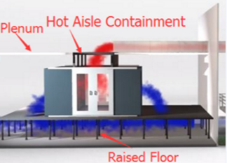

Figure 1‑1: Hot aisle CRAC system

In order to detect the potential problem due to bad air flow design, computational fluid dynamic (CFD) simulation is necessary. Current commercial CFD simulation software includes Fluent, etc. However, in order to speed up the simulation as well as increase the accuracy, many researchers have studied different models, as discussed in the next section. Hence, this report is aimed to create our own 2D Navier-Stokes solver to predict the interior air flow patterns and temperature distribution with different inlet velocity and compare the results with Fluent. The simulation results can be used to help CRAC system designers to identify better CRAC configurations.

# Literature Review

Generally, CFD simulation regarding CRAC can be divided into two categories. The first one is the applications of commercial CFD simulation tool to simulate specific data centers located in different climate zones. The other one is developing numerical simulation algorithm to solve specific CRAC problem. For particular cases, algorithm is improved so as to speed up the simulation while still keep the acceptable accuracy for applied engineers in the industry. N.M.S. Hassan et al. presented a CFD analysis of airflow, temperature and pressure distribution of the data center located at CQ University in Australia. The results show that the maximum inlet and exit temperatures to the rack were observed as 291K and 304K, the range of which is within ASHRAE standard [1]. In addition, Kalish et al. describes a computational fluid dynamics model for calculating airflow rates through perforated tiles in raised-floor data centers. The flow rates through the perforated tiles are shown to be in good agreement with the measured values [4].

Except for the pure application of commercial tools, many researchers also implement their own developed solver to predict the airflow pattern and temperature distribution of indoor condition. The improvement in grid generation, discretization method and numerical solution method have contributed to the increasing speed and accuracy of simulating room ventilation problems such as CARC. For instance, the early method to treat the discretization of convection term in Navier-Stokes equations is central difference in 1950s and 1960s [15]. However, for room air distribution problem, Reynolds number and convex flus are usually high while the diffusion term is small. This could lead to oscillatory or unstable solutions when the grid size is big [16]. A major improvement of this issue the the implementation of upwind scheme, which hold almost unconditional stability [17,18]. The stability condition and its first-order accuracy of upwind scheme make simulation of rom air distribution more efficient and accurate.

Due to small kinematic viscosity of the air, which is $2×{10}^{-5} Pa∙S$ under 293K, usually the turbulence model is implemented for airflow pattern in the data center. To full describe turbulence model, turbulent kinetic $k$ as well as another equation to describe the length scale. A group from Imperial College studied $k$, $k-l$, $k-kl$, $k-ω$ and $k-ε$. They prefer $k-ε$ in considering its standard application [19].

Another commonly used turbulence model in CFD are Reynolds-Averaged Navier-Stokes (RANS) model. For RANS model, the equations are obtained by introducing the Reynolds decomposition where the flow variables are decomposed into a steady and a fluctuating component. To deal with closure problem in RANS equation, Boussinesq hypothesis is employed into $k-ε$ models. For $k-ε$ model, it includes a wall function so that there is no interest to resolve the entire boundary layer [5,6]. To speed up the simulation, Ethan Crus and Yogendra Joshi developed a coupled inviscid-viscous solution method (CITSM) to reduce order. They separated the domains into two parts. One is the viscous domain using the full steady, RANS and the other is the inviscid domain using the Euler equations. The results show that the new algorithm had lower convergence, faster solution times as compared to traditional viscous CFD/HT models [7]. Besides, Qingyan Chen and Weiran Xu also developed a new zero-equation turbulence model to save computing time. The model assumes turbulence viscocisty is a function of length scale and local mean velocity [8]. Moreover, VanGilder et al. also studied the effect of grid size on data center modeling. The result shows that the accuracy improved significantly as average grid size is reduced to about 6’. As grid size is further reduced, improvements are marginal while solution time increases by a factor of 50 [9].

# Navier-Stokes Solver with Finite Difference Method

The computer room air conditioning problem is governed by Navier-Stokes equations. In this project, a simplified 2-D Navier-Stokes solver is developed to simulate airflow pattern and temperature distribution in a typical computer room. To discretize the governing equations, finite difference method (FDM) is applied.

## Model Description

A full Navier-Stokes solver for room ventilation consists of continuity, momentum, energy and turbulence equations. Commonly used turbulence models such as are reviewed by (Zhai, et al., 2007) [10,11]. Those models can be categorized into Reynolds Average Navier-Stokes (RANS) Viscosity model, RANS Reynolds Stress model, Large Eddy Simulation model and Detached Eddy model. However, the whole flow condition could span from laminar to transitional, and to turbulent for room airflow problems. Moreover, the accuracy of those turbulence models varies significantly as different geometry and disturbance occur in different situation. Given the limited time and scale of this project, turbulence model is neglected while the main focus is to develop a simplified Navier-Stokes solver and validate its performance. Thus, the flow of air in a room fluid region $Ω$ throughout time $t=∈[0,t_{end}]$ with energy transport can be characterized by the following quantities [12]:

$\vec{u}: Ω×=∈\left[0,t_{end}\right] velocity field$

$p: Ω×=∈\left[0,t_{end}\right] pressure field$

$ρ: Ω×=∈\left[0,t_{end}\right] density field$

$T: Ω×=∈\left[0,t_{end}\right] temperature field$

In this project, air is considered to be incompressible and Newtonian fluid so that the density change is ignored and has a linear isotropic stress-strain relation).

## Governing Equations

The 2-D Navier-Stokes equation solver has the governing equations as follows:

Continuity equation:

$$\frac{∂u}{∂x}+\frac{∂v}{∂y}=0 (3a)$$

Momentum equations:

$$\frac{∂u}{∂t}+\frac{∂p}{∂x}=\frac{1}{Re}\left(\frac{∂^{2}u}{∂x^{2}}+\frac{∂^{2}u}{∂y^{2}}\right)-\frac{∂\left(u^{2}\right)}{∂x}-\frac{∂\left(uv\right)}{∂y}+g_{x} (3b)$$

$$\frac{∂v}{∂t}+\frac{∂p}{∂y}=\frac{1}{Re}\left(\frac{∂^{2}v}{∂x^{2}}+\frac{∂^{2}v}{∂y^{2}}\right)-\frac{∂\left(uv\right)}{∂x}-\frac{∂\left(v^{2}\right)}{∂y}+g_{y} (3c)$$

Energy equation:

$$\frac{∂T}{∂t}+\frac{∂}{∂x}\left(uT\right)+\frac{∂}{∂x}\left(vT\right)=\frac{1}{Re}\frac{1}{Pr}\left(\frac{∂^{2}T}{∂x^{2}}+\frac{∂^{2}T}{∂y^{2}}\right)+ q^{'''} (3d)$$

Where:

$$Re= \frac{ρVL}{μ} (3e)$$

$$Pr=\frac{υ}{α} (3a)$$

And in this problem, gravity at both x and y direction ($g_{x} and g_{y}$) and internal heat source ${(q}^{'''})$ are ignored.

## Simulation Algorithm

The simulation begins with geometry, boundary type and simulation control parameter input. To avoid serious oscillations of pressure value, a staggered grid mesh is then generated [12]. The main time-stepping simulation loop starts after initialization. An adaptive time step is calculated for stability purpose. Boundary values of the matrices of x-velocity (U), y-velocity (V) is updated at each time step n. Then the values of temperature (T) at each cell in fluid domain at (n+1) time step is solved. With that, a linear system of pressure values (P) is solved with Poisson solver with successive over-relaxation (SOR). With pressure values (P) at (n+1) time step, x-velocity (U) and y-velocity at (n+1) time step can be solved. Simulation time and step are updated after each main iteration. The whole simulation terminates when simulation time is greater or equals to desired end time. The algorithm is shown in the flowchart (Figure 3‑1).

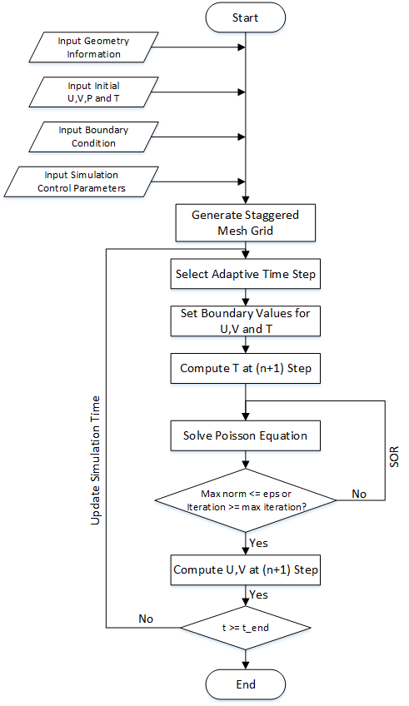

Figure 3‑1: Simulation Algorithm Flowchart

# Geometry Simplification & Mesh Generation

## Geometry Simplification

**4.1.1 Geometry and Boundary conditions of CRAC model**

The physical model is shown in Figure 4‑1. Since the data center contains many rack servers, we just investigate the airflow patterns as well as temperature distribution surrounding one server, which is defined as one space cell. Since the space cell is created as symmetric geometry, the calculation is conducted in half of the whole space cell. The dimension of each component in our model is shown in Table 4‑1.  We simplified the model to see the server as a solid obstacle, which belongs to obstacle domain while the flowing air within the room belongs to fluid domain. The temperature and velocity conditions is shown in both Table 4‑2.

Table ‑ Dimension of CRAC

|  |  |
| --- | --- |
| Parameter | Value |
| Height of the space cell | 2.5m |
| Length of the space cell | 2.2m |
| Diameter of the inlet | 0.2m |
| Diameter of the outlet | 0.3m |
| Height of the server | 1.2m |
| Width of the server | 0.3m |



Figure 4‑1: Space cells of CRAC

Table ‑ Temperature conditions

|  |  |
| --- | --- |
| Parameter | Value |
| Room temperature | 298K |
| Server temperature | 318K |
| Supply air temperature | 293K |
| Case 1: inlet velocity | u=-1m/s, v=1m/s |
| Case 2: inlet velocity | u=0m/s, v=1m/s |

**4.1.2 Geometry and Boundary conditions of lid-driven cavity model**

Several studies are made of flow and heat transfer of a viscous fluid contained in a square cavity, especially heat transfer problem within lid-driven cavity [20]. Therefore, lid-driven cavity CFD model coupled with energy equation using in our solver is established with the geometry shown in Figure 4‑2**错误!未找到引用源。**. The dimension and the boundary conditions of the model are listed in Table 4‑2 Temperature conditions.

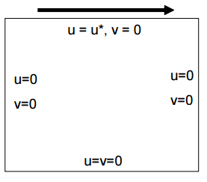

Figure ‑: Lid-driven cavity model

Table ‑: The dimension and boundary conditions of lid-driven cavity model

|  |  |
| --- | --- |
| Temperature of the top side | 350K |
| Temperature of the bottom side | 300K |
| Thermal conditions of left side and right side | adiabatic |
| Length of each side | 1m |
| u* | 1m/s |
| Temperature of the top side | 350K |

## Mesh Generation

As mentioned in 3.3, the proposed solver employs staggered grid to prevent possible pressure oscillations. In this approach, x-velocity, y-velocity and pressure are discretized on three different locations of the mesh grid [13]. Pressure and temperature are discretized at the center of each cell, x-velocity and y-velocity are discretized at the right and up edge of the cell respectively. The following figure shows the discretization locations of u, v, p and T.

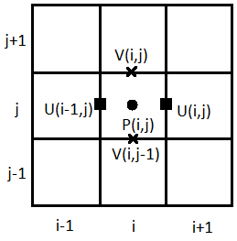

Figure 4‑3: Discretization Location of U,V and P

As described in 4.1, the base domain $Ω$ is separated into solid domain and fluid domain (Figure 4‑4). The length of fluid domain (horizontal direction) is divided into 88 parts, the height of the fluid domain (vertical direction) is divided into 200 parts. To compute U and V values at the edge of fluid domain, a solid domain is added to the perimeter of fluid domain. The internal of the obstacle is also considered as solid domain. In order to label different kind of cell in fluid domain and solid domain, a flag matrix $(90×202)$ is introduced at initialization stage to store the cell type information of all the cells in base domain.

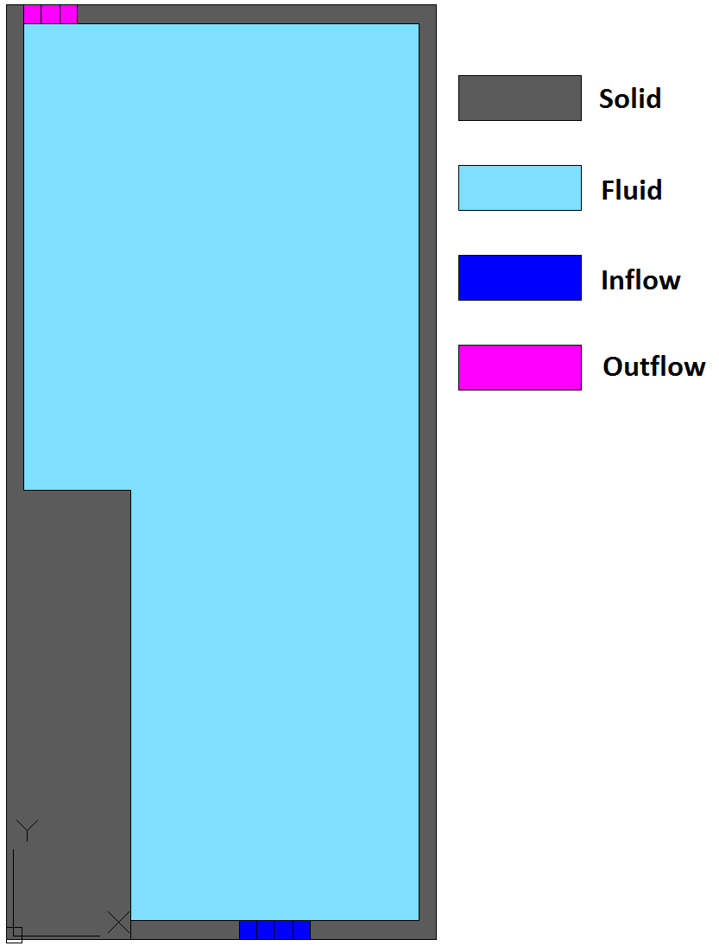

Figure 4‑4: Domain separation

In the simulation loop, U, V values will be set for the boundary cells in solid domain only at set boundary stage. During computation of T, P, U and V stages, only fluid cells will be considered. The process is facilitated with the help of the staggered grid and cell flags.

## Boundary settings

Boundary conditions are critical in numerical simulation. During setting boundary stage, both velocity and temperature boundary conditions will be set. Figure 4‑5 and Figure 4‑6 below indicate the type of boundary conditions for velocity and temperature computation in this study.

|  |  |
| --- | --- |
|  |  |
| Figure 4‑5: Velocity boundary conditions | Figure 4‑6: Temperature boundary conditions |

Figure 4‑7 through Figure 4‑10 below show the value setting for inflow, outflow, no-slip and symmetry boundary.

|  |  |
| --- | --- |
|  |  |
| Figure 4‑7: Inflow cell | Figure 4‑8: Outflow cell |

|  |  |
| --- | --- |
|  |  |
| Figure 4‑9: No-slip cell | Figure 4‑10: Symmetry cell |

# Simulation Procedure

In the current phase of this study, two case studies are conducted. In the first case (CRAC problem), only velocity and pressure field were simulated. In the second case (Lid-driven cavity problem), velocity, pressure field are considered. And energy model is coupled to validate its accuracy. In both cases, the parameters are dimensional. The solver is developed in $Matlab®$ programming environment. To compare the simulation result, a model with same initialized parameter settings are created with $ANSYS Fluent®$. The calculation in Fluent is SIMPLE, with same relaxation parameter in our Navier-Stokes solver.

## CRAC simulation

In this case, model geometry is same as described before. Two parametric studies of the inlet velocity are carried out. The detailed initialization parameters are in Table 5‑1

Table ‑: Initialization of CRAC simulation

|  |  |
| --- | --- |
| Parameter | Value |
| Inlet x-velocity $U_{inlet}$ | Case 1: -1 m/s ; Case 2: 0 |
| Inlet y-velocity $V_{inlet}$ | Case 1: 1m/s; Case 2: 1m/s |
| Gravity at horizontal direction $g_{x}$ | 0 |
| Gravity at vertical direction $g_{y}$ | 0 |
| Outlet relative pressure $P_{outlet}$ | 0 |
| Reynolds number $R_{e}$ | 17,000 |
| Simulation end time $t_{end}$ | 30s |
| SOR maximum iteration ${Iter}_{max}$ | 100 |
| SOR relaxation parameter $ω$ | 0.7 |
| SOR tolerance | 0.001 |
| Upwind differencing factor $γ$ | 0.9 |

## Lid-driven cavity problem

Simulation initial parameter inputs are shown in Table 5‑2.

Table ‑: Initialization of Lid-driven simulation

|  |  |
| --- | --- |
| Parameter | Value |
| Top lid velocity $U_{lid}$ | 1 |
| Top edge temperature $T_{top}$ | 350K |
| Bottom edge temperature $T_{bottom}$ | 300K |
| Cavity initial temperature $T_{cavity}$ | 325K |
| Gravity at horizontal direction $g_{x}$ | 0 |
| Gravity at vertical direction $g_{y}$ | 0 |
| Reynolds number $R_{e}$ | 1,000 |
| Prandtl number $P_{r}$ | 0.7 |
| Simulation end time $t_{end}$ | 20 s |
| SOR maximum iteration ${Iter}_{max}$ | 100 |
| SOR relaxation parameter $ω$ | 0.7 |
| SOR tolerance | 0.001 |
| Upwind differencing factor $γ$ | 0.9 |

# Result & Comparison

**6.1.1 Steady state comparison of CRAC model**

Figure 7-1 demonstrates the u velocity along the x-axis at the height of 0.6 m with our own solver and fluent at t=30s. As shown in the figure, the trend of v-velocity is similar while the value of the u-velocity varies, especially from x=0 m to x=0.85m.

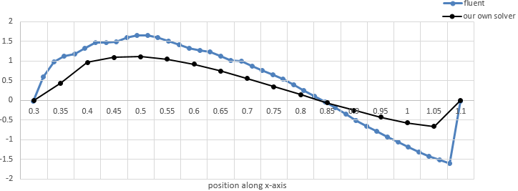

Figure 6‑1: y-velocity comparison of Fluent & our N-S solver

**6.1.2 Transient comparison of CRAC model**

In order to furtherly compare the airflow patterns simulated by our own solver and fluent, transient models are also established to show the airflow development over the time. As mentioned in the section 4, two cases are studied. As to case 1, Figure 6‑2, Figure 6‑4, Figure 6‑6 and Figure 6‑8 show the airflow patterns from beginning t=1s to t=10s, which were simulated with our own solver. Figure 6‑3, Figure 6‑5, Figure 6‑7 and Figure 6‑9 show the airflow patterns at the same time, which were simulated with fluent. As to case 2, Figure 6‑10, Figure 6‑12, Figure 6‑14 and Figure 6‑16 show the airflow patterns from beginning t=1s to t=10s, which were simulated with our own solver.  Figure 6‑11, Figure 6‑13, Figure 6‑15 and Figure 6‑17 show the airflow patterns at the same time, which were simulated with fluent. Based on the results, both cases have similar airflow patterns at different time.

***Case 1: u = -1 m/s, v = 1 m/s***

|  |  |
| --- | --- |
| https://lh4.googleusercontent.com/ojzk-QTu0pzjWQoXUfb3PN5T4Y9G14Vk3ecdne2QfelS7H1BaSVqdNZScCqm9LUlx3A02Pa21wh7_1U2IggRoV1xcrGFjnwLNnNIlLp_lVRu9wg6vQ2UG3lvOuHG9-NU7rC9OWqJ | https://lh4.googleusercontent.com/TY7ntmWeylcy1rgT7od1azgut6roiTnjwUnYE99Mmg146R8AoIbr5PGQyO50123-b2vTesgqlrxVPj06zi3SMqIwFla31JueaTbikigN5KdqEByiuWmM_GkFqShvxUea0TuI1heN |
| Figure 6‑2 | Figure 6‑3 |

|  |  |
| --- | --- |
| https://lh6.googleusercontent.com/5epOX6H59qrg4WqwI5dIJkM8Wq7vvTNSkONLCRH7-REdXAk_XaHJyPH3uGiTTSjTxnwQqhncbWq_1QtZT8w_Q3yboS6g6zPZjt5DLpdqjmCp66Hn1yG8VXEx6Sc8W5rl8-LtsfnC | https://lh4.googleusercontent.com/UV6sKUJORtXa5M9SZwSOc-e-K96n9Tgv-AVQgVrR_WsOt162tNxuLPYjqgJM-UQPJz6JT2eSN_wCmCXo7Iec9OFUJGqpsYwkBFEjXr7V_qMNvtIVUKDVCG9GGGanmZedLP-bl4Vh |
| Figure 6‑4 | Figure 6‑5 |

|  |  |
| --- | --- |
| https://lh4.googleusercontent.com/QyFT9mSoZUnitvrUJ5kbU4rEA8xOQWQ3pS4wDmltCzZPzla83XJby2VsPHo3UWdNh9COoawD3rtoDaTSKiZVCXFOu0ZvX2uu0_FnI5hp6UYDyU8oyhx9alpeiID29wcDTvYUzsvz | https://lh3.googleusercontent.com/jEp1x46D-qnh4-tO7SoqO1kEO0Mr4w2Ta8IN0UD_gCuTbxpy5BZhUA-_amcLjLDxCh9Oy0fOs9OdgByfO3U5BcXgo7ZXZn8yU17XKFj4V_975gc-yNwovZiyg8UATq_4UoMi8-Fs |
| Figure 6‑6 | Figure 6‑7 |

|  |  |
| --- | --- |
| https://lh3.googleusercontent.com/rCLg3JeF6EKX4Gnn7hbJW4jmUGiXHxbCr1wrbtWYzL83saPchF-C73gbH7VTu9j5o-WrJWck3sFvEg9vKCQpT3tHKzftJbg3kN1gy6V3Ti_PLET0GwqDhW1ZfFDQmSVjDW2pZTQ6 | https://lh3.googleusercontent.com/ivHY4KjKrTplrZSUFTAyiZfVFr9esTc_w5OeiUmBpsmHH-Zx30eEyLbwfywcglv0PhhJ4nf7F7VKIBHlwKbbOyDyk5tV2R1ML6gUeXuzeUA6Cyo30iJ18eeXQpja_vF6SCSCINe6 |
| Figure 6‑8 | Figure 6‑9 |

|  |  |
| --- | --- |
| https://lh6.googleusercontent.com/3WZwITowCKgpun6PHY46daapH3v7cjFqmAU4d1JKZbzz5HIA3kKa-iRuc4TD-_GRnGtDfBZ2ZXadpTKjKt4AZyv5ZguhYovxWLbiHrDWyeg2lfqw9jwinda2TybBYC0KRl3uQrYE | https://lh6.googleusercontent.com/vh74fNs788O44o4NmIms-ok_EVUpuxbTXMvwito7CZJTasHliCuEPMEpR3HAcwYSLdpfyeOmQlcmb00xR0pELeP_uyMyZpCtubwd7wMNiwGvVQI-0lI8Blzbat4_nVSBWOMTT89A |
| Figure 6‑10 | Figure 6‑11 |

***Case 2: u = 0 m/s, v = 1 m/s***

|  |  |
| --- | --- |
| https://lh4.googleusercontent.com/1Gs5UoLMbrkjLXV7s5kJWUXX54hsiVO127ghU5QFKchGHvGiXxhXwtEmlRs9YNHW3Vg40GuTvQLo3ArlEfzGoYp8hAHlY_o57esDi-QCs6GqbZ8VK6efsHvxR75kU2nhRHJIpqOK | https://lh4.googleusercontent.com/TY7ntmWeylcy1rgT7od1azgut6roiTnjwUnYE99Mmg146R8AoIbr5PGQyO50123-b2vTesgqlrxVPj06zi3SMqIwFla31JueaTbikigN5KdqEByiuWmM_GkFqShvxUea0TuI1heN |
| Figure 6‑12 | Figure 6‑13 |

|  |  |
| --- | --- |
| https://lh3.googleusercontent.com/y2spdjOiKMP672QWJ1N015Q2kuAyUFu4zwqykQgFx8bK8HUvhoWBS-bSwJzkC87QQdesR9qqLF4pLYijNkHC8U1nCCWiy316vNwQLprOZP95Rrm0HLKg77WPqClGPDqhRY46W_eY | https://lh3.googleusercontent.com/dSaXtDpgpgUVV78wiHfz_f3PMH_ElF_iLjv6uZuu5wmySNdpfT9dfb-XcI9YeX-sYdd_GWt84fwWotbsiEg3TZVdIuGXS9ocQGVsevkBU7VeusQzI9oYR2vqvnUtYG2SJyTyRfvC |
| Figure 6‑14 | Figure 6‑15 |

|  |  |
| --- | --- |
| https://lh6.googleusercontent.com/ISbBBNmMhNQmmR3HfkZtPtLJkttimx0Xd7zdmKh35InxWtpxBIYFUOABEd53A5_1sXb8kjtBn0X2HaME7KOcGuHYxoGtaO3lQZVYhnG33bhkFS9VViwcXO1Qmdj75EhIDjGYMvrs | https://lh6.googleusercontent.com/jG6EeBxRgzc4g3cIpkuD3XjrBA_66schG64C45-rBESRqaBlhek_qDom03ip2-G_cpfmzQzNEFgg5opUEQI_UhCeslBjcaOdtevKlzY1dgZJ1M1pbJgyCG2Qz-6XggE88u1m9WC_ |
| Figure 6‑16 | Figure 6‑17 |

In addition, comparing the airflow patterns of two different cases, it can be observed that in case 1, supply air directly contacts with the server surface while in case 2, supply air indirectly contacts with server surface after hitting the ceiling and part of the air flowing back. Due to differences of these two cases, we suppose that the case 1 has better cooling performance.

**6.1.3 Temperature distribution of CRAC model with fluent**

In order to verify our hypothesis, temperature distribution of these two cases were simulated with fluent, as shown in Figure 6‑18 and Figure 6‑19. As a result, the temperature distribution of case 1 is more uniform than that of case 2. With the same temperature scale, it can be observed that the case 1 indeed has better cooling performance than case 2, which illustrate that it is better to have the supply air directly contacts with the surface cool the server. However, since we assume the server as solid, supply air cannot flow into the server. Therefore, the cooling performance of the simplified model is not as good as the CRAC system in reality.

|  |  |
| --- | --- |
| https://lh4.googleusercontent.com/3WwQ1tGsgHQM0IOVbiAbr66TXsPNHmGLh61CdTJ45YtpxXr9ggF9Pdiv41qUoyKEUyXieV4Vwr0JiIygE4AuUZwIuv3wtKqGP3smNr9G7YPwxHudzTuHxLFhof24dulqj3l4Up61 | https://lh3.googleusercontent.com/Jb6VGSrJLjbCTAmqHRXh7CXiCte9mSOkx9wpq_fl4xAtZN12IJxM1N0KHApltg95CD-iYpTFmGgIvpBu1h2y8__Pa2wFDXCj43lOUlH14JFAwHA4rQ4ANsKMMbacB3GqvsBGhecj |
| Figure 6‑18 Steady state temperature field of case 1 | Figure 6‑19 Steady state temperature field of case 2 |

**6.2.1 Steady State Temperature comparison of Lid-driven cavity model**

To validate the accuracy of the 2-D Navier-Stokes solver coupled with energy equation. A lid-driven cavity case study is implemented. The figures below are the results of temperature contour at t=20s of our Navier-Stokes solver (Figure 6‑20) and steady state result of Fluent simulation (Figure 6‑21). Temperature distribution at x=0.5 section is shown in Figure 6‑22.

|  |  |
| --- | --- |
|  |  |
| Figure 6‑20 Steady state temperature contour of our solver | Figure 6‑21 Steady state temperature contour of Fluent |
|  |  |
|  | |
| Figure 6‑22: Our solver vs. Fluent | |

As the figures indicate, the temperature distribution of Fluent result and our solver match with each other well in terms of temperature gradient. The discrepancy between them may because the simulation time in our solver is only 20s so that the solution is not actually steady.

# Conclusion

A 2-D, incompressible, Newtonian, laminar Navier-Stokes solver with finite difference method is developed to predict the airflow distribution in a section of computer room in a data center. Two kinds of inlet air patterns were compared to examine the airflow pattern around a server in the room. Corresponding finite volume method models were developed with $ANSYS Fluent®$. Both steady state and transient airflow velocity field results are compared between our solver and Fluent. The steady state (t=30s) results indicate that there is a good match of y-velocity at the center position of the server (height=0.6m) with the first inlet velocity pattern. The transient results indicate that from t=1s to t=10s, the development of velocity field in our solver and Fluent are pretty similar in both inlet velocity patterns. Out of the two patterns, the first one has more appropriate velocity distribution. The temperature distribution at the right surface of the server also indicate that the first velocity inlet pattern has the better cooling performance. In the preliminary stage of this study, our solver coupled with energy equation is applied to simulate the temperature distribution in lid-driven cavity problem. The result of our solver (t=20s) shows the same trend with Fluent steady state temperature contour in the whole domain. And the temperature distributions at center of the cavity (x=0.5m) along y direction match well in our solver and Fluent. It is proved that our Navier-Stokes solver could predict room air velocity field in incompressible, Newtonian, laminar condition. Coupled with energy model, the solver could predict both transient and steady state temperature distribution with simple geometry and boundary conditions input. However, extensions should be included for the solver in order to simulate room air distribution with turbulence flow. And our solver could be optimized to gain more accuracy in simulation of temperature with complex geometry and boundary conditions.

# Future Work

Based on our current work, following future work can be done to further improve our solver algorithm and increase the accuracy of the simulation:

* Since Reynolds number of the CRAC model is 17000, it should be more accurate to apply turbulence model. Therefore, we need to implement turbulence model by using k-epsilon equations or RANS in our own solver.
* Currently, we assume that air will not be affected by buoyancy force. However, buoyancy force will affect the airflow patterns when the air is heated by server. Therefore, we will apply Boussinesq approximation to simulation air density.
* So far, our server is simulated as solid. However, in real case, supply air will flow into the server to cool racks and other electronic devices. Therefore, in order to get more accurate result, we will change the server’s geometry by leaving gaps so that the cooled air can be fully used.
* Last but not least, temperature distribution of the CRAC model with our own solver still has had something incorrect in several parts like the corner of the server as well as the ceiling by now. We will figure it out to analyze the temperature distribution of CRAC model with our own solver.

# Acknowledgement

The authors sincerely appreciate the instruction from Prof. Higgs and the guidance from TA Prathamesh in the CFD course from Carnegie Mello University. With their support and help, the authors gained the opportunity to have deeper understanding of principles behind CFD. The author would also like to thank the peers in the CFD class for their inspirations.

# References

[1] Hassan, N.M.S., Khan, M.M.K. and Rasul, M.G., 2013. Temperature monitoring and CFD analysis of data centre. *Procedia Engineering*, *56*, pp.551-559.

[2] Ashrae, T.C., 2011. 9.9 (2011) Thermal guidelines for data processing environments–expanded data center classes and usage guidance. Whitepaper prepared by ASHRAE technical committee (TC), 9.

[3] Beaty, D. and Davidson, T., 2005. Datacom airflow patterns. ASHRAE journal, 47(4), p.50

[4] Karki, K.C., Radmehr, A. and Patankar, S.V., 2003. Use of computational fluid dynamics for calculating flow rates through perforated tiles in raised-floor data centers. HVAC&R Research, 9(2), pp.153-166.

[5] Iyer, G.R. and Yavuzkurt, S., 1999. Comparison of low Reynolds number k–ε models in simulation of momentum and heat transport under high free stream turbulence. *International journal of heat and mass transfer*, *42*(4), pp.723-737.

[6] Cruz, E. and Joshi, Y., 2015. Coupled inviscid-viscous solution method for bounded domains: Application to data-center thermal management. *International Journal of Heat and Mass Transfer*, *85*, pp.181-194.

[7] Chen, Q. and Xu, W., 1998. A zero-equation turbulence model for indoor airflow simulation. *Energy and buildings*, *28*(2), pp.137-144.

[8] VanGilder, J.W. and Zhang, X.S., 2008. Coarse-Grid CFD: The Effect of Grid Size on Data Center Modeling. *ASHRAE Transactions*, *114*(2).

[9] Versteeg, H.K. and Malalasekera, W., 2007. An introduction to computational fluid dynamics: the finite volume method. Pearson Education.  
[10] Zhai, Z. J., Zhang, Z., Zhang, W., & Chen, Q. Y. (2007). Evaluation of various turbulence models in predicting airflow and turbulence in enclosed environments by CFD: Part 1—Summary of prevalent turbulence models. *Hvac&R Research*, *13*(6), 853-870.

[11] Zhai, Z. J., Zhang, Z., Zhang, W., & Chen, Q. Y. (2007). Evaluation of various turbulence models in predicting airflow and turbulence in enclosed environments by CFD: Part 2—Summary of prevalent turbulence models. *Hvac&R Research*, *13*(6), 853-870.

[12] Griebel, M., Dornseifer, T., & Neunhoeffer, T. (1997). Numerical simulation in fluid dynamics: a practical introduction (Vol. 3). Siam.

[13] Rannacher, R., 1993. On the Numerical Solution of the Incompressible Navier‐Stokes Equations. ZAMM‐Journal of Applied Mathematics and Mechanics/Zeitschrift für Angewandte Mathematik und Mechanik, 73(9), pp.203-216.

[14] Gao, C., Yu, Z. and Wu, J., 2015. Investigation of Airflow Pattern of a Typical Data Center by CFD Simulation. Energy Procedia, 78, pp.2687-2693.

[15] Nielsen, P.V., 2015. Fifty years of CFD for room air distribution. Building and Environment, 91, pp.78-90.

[16] Patankar, S., 1980. Numerical heat transfers and fluid flow. CRC press.

[17] Courant, R., Isaacson, E. and Rees, M., 1952. On the solution of nonlinear hyperbolic differential equations by finite differences. Communications on Pure and Applied Mathematics, 5(3), pp.243-255.

[18] Gosman AD, Pun WM, Runchal AK, Spalding DB, Wolfshtein M. Heat and mass  transfer in recirculating flows. London: Academic Press; 1969.

[19] Launder, B.E. and Spalding, D.B., 1972. Lectures in mathematical models of turbulence.

[20] Iwatsu, R., Hyun, J.M. and Kuwahara, K., 1993. Mixed convection in a driven cavity with a stable vertical temperature gradient. International Journal of Heat and Mass Transfer, 36(6), pp.1601-1608.